Document Number: 1 | Copy Number: 1



GlobalX Funds Transfer Multibanking System
India

Funds Transfer Multibanking System
User Manual Version <1.0>

February, 2013

DOCUMENT RELEASE NOTICE
Notice No. | 1
Client | GlobalX
Project | Funds Transfer Multibanking System
Document details

Name | Version No. | Description

Revision details:
Action taken  (add/del/chg) | Preceding  page No. | New  page No. | Revision  description

Change Register serial numbers covered:
The documents or revised pages are subject to document control.
Please keep the documents up-to-date using the release notices from the distributor of the document.
These are confidential documents. Unauthorized access or copying is prohibited.

Approved by : _GlobalX_________ Date: _________

Authorized by: _________________ Date: _________

DOCUMENT REVISION LIST
Client | GlobalX
Project | Funds Transfer Multibanking System
Document Name | User Manual
Release Notice Reference (for release) | 1

Rev.  No. | Revision  date | Revision  description | Page  No. | Prev  page No. | Action  taken | Addenda/New page | Release  Notice reference

PREFACE
Purpose :
This document gives the clear idea of Funds Transfer Multibanking System for the user.
Audience :
Customer
Admin
Development team
Testing Team

Prerequisites :

The User should have the prior Knowledge of Funds Transfer Multibanking System.

About this volume :

This volume (Volume I) is written to help you to understand and use Funds Transfer Multibanking System. It contains the procedures that you must follow in Funds Transfer Multibanking System to accomplish various tasks.

Organisation of the Manual :

The User Manual for the Funds Transfer Multibanking System is contained in one volume as follows:

Volume Number | Contents
I | Chapter 1 provides a brief introduction to Funds Transfer Multibanking System. It also details the hardware and software requirements and Interfaces with other systems.  Chapter 2 takes you on a quick tour of Funds Transfer Multibanking System. It gives a brief introduction about the general working features of Funds Transfer Multibanking System that you should keep in mind while working.  Chapter 3 Works with Funds Transfer Multibanking System.It explains the key terms being used and the Navigates across the fields  Chapter 4 Describes the System Administration functions. These activities are to be performed by the system administrator.  Chapters 5 Gives a detailed description of all the screens along with their input and output details.  Appendix A It gives a list of all the error messages displayed and the steps to be taken.

Note: Since Chapters 1 to 3 contain general information about Funds Transfer Multibanking System, you should read these three chapters before proceeding with specific task-related procedures explained in Chapter 4

Abbreviations and Acronyms Used :

Abbreviation/Acronym | Description
FTMS | Funds Transfer Multibanking System
SP | Service Provider
GUI | Graphical User Interface

CONTENTS

CHAPTER -1 INTRODUCTION 1
1.1 Welcome to Funds Transfer Multibanking System 1
1.2 Funds Transfer Multibanking System Modules 1
1.2.1 Payee Profile 1
1.2.2 Funds Transfer 1
1.2.3 Request Management 1
1.3 Funds Transfer Multibanking System Environment 2
1.3.1 Hardware Environment 2
1.3.2 Software Environment 2
Setting Up Funds Transfer Multibanking System 3
1.4 Before Installing Funds Transfer Multibanking System 3
1.5 Funds Transfer Multibanking System Components 3

CHAPTER-2.a quick tour of Funds Transfer Multibanking System 4
2.1 Starting and Quitting Funds Transfer Multibanking System 4
2.1.1 Starting Funds Transfer Multibanking System 4
2.1.2 Quitting Funds Transfer Multibanking System 4
2.1.3 Funds Transfer Multibanking System Menu Options 4
2.1.4 Funds Transfer Multibanking System Menu 4
2.1.5 Funds Transfer Multibanking System Menu 4
2.1.5.1 Payee Profile 4
2.1.5.2 Funds Transfer 4
2.1.5.3 Request Management 6

CHAPTER 3.Working with Funds Transfer Multibanking System 6
3.1 Definition of Key Terms 6
3.2 Navigating across Fields 6
3.2.1 Payee Profile 6
3.2.2 Funds Transfer 6
3.2.3 Request Management 6

CHAPTER 4.system administration 6
4.1 Introduction 6
4.2 Transferring Data 6
4.3 Maintaining System Security 6
4.3.1 Maintaining Roles 6
There are only two roles in this system 6
4.3.2 Maintaining Users 6
4.3.2.1 Managing Request 6

Chapter 5.Maintenance 7
5.1 Introduction 7
5.2 Maintaining Login page 7
5.2.1 Maintaining Add Payee Page 7
5.2.2 Maintaining View Payee Details/Status Page 7
5.2.3 Maintaining Update Payee Details Page 7
5.2.4 Maintaining Delete Payee details Page...............................................................................7
5.2.5 Maintaining View Transaction History Page..........................................................................7
5.2.6 Maintaining Funds Transfer Page..........................................................................................7
5.2.7 Maintaining Manage Request Page.......................................................................................7
The total number of pages in this document, including the cover page is 29

INTRODUCTION

Welcome to GlobalX Multibanking System
The Caress Insurance Limited Company has helped Indians since 1990 protect themselves and their families from the financial hardship that often comes with critical illness, accidents or loss of life. Our supplemental health and life insurance products are designed to help give you and your loves ones peace of mind. You can depend on us to be a strong, caring partner in helping to provide financial security for you and your family.
We’re financially strong, with more than $4.4 billion of assets and $3.4 billion of policy reserves. We insure more than 1 million policyholders and 25,000 employer groups, encompassing a broad spectrum of industry types and sizes. You can be confident in our ability to meet our policyholder obligations. In all, Caress Insurance Limited has paid out more than $2.5 billion to our supplemental health policyholders— more than $1.1 billion in claims to help protect customers from the costs of illnesses, injuries and accidents, and another $1.4 billion through our special return-of-premium and cash-value benefits.

Trouble Caress Insurance Limited

Proposal Management
Agent will enter the details given by the customer on the page that is created to take the input details. Database should be built up to store the details keyed in by the agent. Page should allow verification of the customer details in the history database. Only if the customer is a clean case, a Submit facility should be enabled in the page. Status of the Proposal should be set as “Submitted” once all the details of the proposal have been keyed in by the agent. A page should be available to generate a status report of proposals based on the options keyed in by the user. An option to authorize / Reject the Proposal should be available in the online screen for only the Authorizing Team (Underwriting Team). Database created in Proposal submission is reused and the record is flagged to the new status of “Authorized” / “Rejected” from “Submitted”. A unique Policy number will be issued once the status is changed from “Submitted” to “Authorized”.Premium will be generated from that moment.

Loan
Customer provides details for a loan request to the agent or directly at the Life Office. Life Office Clerk/Agent enters the policy number and loan amount into the system and those details should be stored in the database. All details regarding the policy and loan eligibility should be displayed if the given policy number exists in the database otherwise an error message is displayed stating “invalid policy number”. Life Office Clerk/Agent submits the loan request only if the loan eligibility amount is greater than amount requested and if the policy number exists in the database.

Customer provides details for updating a loan request to the agent or directly at the scope
Life Office. Life Office Clerk/Agent enters the policy number into the system .All details regarding the policy and loan eligibility should be displayed if the given policy number exists in the database otherwise an error message is displayed stating “invalid policy number” Life Office Clerk/Agent updates the loan amount requested in the loan request and also other details which customer want to change.

Life Office Officer enters the policy number into the system. All details regarding the policy, loan eligibility and existing loan details should be displayed if the given policy number exists in the database otherwise an error message is displayed stating “invalid policy number”.Life Office Officer Authorize/Reject a loan request.
Life Office Officer enters the policy number into the system.Details of loan request are displayed if the loan request is in rejected status. Life Office Officer deletes a loan request.

Claim Management
There are four tasks in this Management. They are:Raise a new claim,View claim,Update an existing claim,Authorize a claim,View the Cheque details

In raise claim , customer is the user and he enters the type of claim, the branch of the Life Office he is claiming, the originator name and date. The system gives the details. Once the submission is done, a unique claim ID is generated and given to the user. The user can also cancel the entries and enter fresh details.
In view claim, the user will be shown all the details he entered for the claim. He/she can either choose to update a claim. He/she can go back for Claim Credentials.
To view or authorize a claim, the Under Writer has to give the unique claim ID. Under Writer can view the details of his claim. The details submitted by claim owner will be Subject to authorize/Reject Proposal. The authorization details will be reflected in the status of the Claim

Caress Insurance Limited System Environment

Hardware Environment
- Server : Linux 2.6.18-194.el5 x86_64
- Processor: Core2Duo, 3.00 GHz frequency
- RAM: 2 GB

Software Environment

- OS : Windows XP Professional, Version 2002, Service Pack 3
- Software: putty, winscp
- Visual Studio 2010
- Database server: MS SQL Server 2008

setting up Globalx multibanking system

Before Installing GlobalX Multibanking System
The software visual studio 2010 and SQL server management studio should be installed in the system.

CHAPTER-2.a quick tour of Globalx multibanking System

2.1 Starting and Quitting GlobalX Multibanking System

2.1.1 Starting GlobalX Multibanking System
For starting the system, the first page is the Login page. Here the user enters its credentials. The user can either be a customer or admin. The user is required to enter the correct user ID, password and role. After this they are directed to their respective home pages.

2.1.2 Quitting Caress Insurance Limited System
Once the task is completed both the admin and the customer quits the system by logging out.

2.1.3 GlobalX Multibanking System Menu
The main menu includes links to Home and Login.
On clicking on Home, the user is redirected to the respective Home page from whatever page he/she is in.

The Login Page allows registered users to log into the website and based on their role, they are redirected to their respective accounts.

2.1.4 Funds Transfer Multibanking System Menu

2.1.4.1 Payee Profile
This module has four links.

Add Payee Details: This page allows the customer to add details of the payee for transferring the funds.

View Payee Details page: This page is to view the details of the added payee. Also a customer can view the status of the request for adding payee.

Update Payee Details: Here the customer can update the details of Payee whose request is either approved or pending.

Delete Payee Details: This page allows the customer to delete the added payee details.

2.1.4.2 Funds Transfer
This module has two links.

Transfer Funds: This page allows the customer to transfer funds from one of his account to his another account or to the account of added payee.

View Transaction History: This page allows the customer to view all previous transactions made by him.

2.1.4.3 Request Management
This module has a single page of manage request.

This page allows Admin to view all the details of the payee added by the customer.
Admin can check whether the account of the payee is registered account of the GlobalX Multibanking System or not. Also he can check for active or inactive account. Based on the details provided by the customer he validates the information and decides whether to accept or reject the request.

CHAPTER 3: Working with Funds Transfer Multibanking System

3.1 Definition of Key Terms
The key terms used are:
Adding Payee : A new payee is added .
Funds Transfer : Transferring funds from one account to another.
Request Management : Admin accepts or rejects the request for adding new payee.

3.2 Navigating across Fields

3.2.1 Payee Profile
This module has three links.

Add Payee Details: This page allows the Customer to enter all the mandatory details of the payee in correct format. On successful submission of details, request will be in pending state and will be sent to the Admin for approval.

View Payee Details: This page allows the customer to view all the information of added payee along with their status of the request. Also he can sort these details based on the desired information column by clicking on the header of the column.

Update Payee Details: This page allows the customer to update the details of Payee whose request is either approved or pending. Also he can sort these details based on the desired information column by clicking on the header of the column.

Delete Payee Details: This page allows the customer to delete the added payee details. Also he can sort these details based on the desired information column by clicking on the header of the column.

3.2.2 Funds Transfer
This module has two links.

Transfer Funds: This page allows the customer to transfer funds from one of his account to his another account or to the account of added payee. First the customer has to select type of payee (Self/third party) for transaction. Based on this selection list of payee accounts will get displayed.
Then the customer has to select one of these accounts and has to enter the amount to be transferred along with the remark details (Optional). On successful transaction, transaction details will be displayed along with the available and updated balance of the customer.

View Transaction History: This page allows the customer to view all previous transactions made by him. Also he can sort these details based on the desired information column by clicking on the header of the column.

3.2.3 Request Management
This module has a single page of manage request.

This page allows Admin to view all the details of the payee added by the customer.
Admin can check whether the account of the payee is registered account of the GlobalX Multibanking System or not. Also he can check for active or inactive account. Based on the details provided by the customer he validates the information and decides whether to accept or reject the request. If the admin rejects the request, it is mandatory for him to provide the reason for rejection.

CHAPTER 4.system administration

4.1 Introduction
The system deals with the storing and retrieving of data into and from the database.

4.2 Transferring Data
For all the modules whenever a new user makes an entry the data is entered in the data base. The insert operation is performed.
Next whenever an update is done the user enters the details and the update operation is performed.
Next read operation is performed whenever the user wants to view status for any of the modules.
Next delete operation is performed whenever the customer wants to delete the details of any module.

4.3 Maintaining System Security

4.3.1 Maintaining Roles

There are only two roles in this system
1. Customer
2. Admin

Whenever a new user is registering the user will be assigned the role of customer.

The admin is fixed and there is no chance of registering a new admin.

4.3.2 Maintaining Users

4.3.2.1 Login

The user should login with the credentials in order to check his/her details and for raising a fault and for the updation or closing of the faults

4.3.2.2 Adding User Details
The user is provided with the user registration page .This is how a new user is added to the system.

4.3.2.3 Modifying User Details
The modification of user details can be done using the update user details page.

4.3.2.4 Deleting User Details
The user details are not deleted from the database in any of the occasions.

4.3.2.5 FORGOT PASSWORD
If the user forgets his/her password he can approach the link of forgot password, where he will be asked to answer the security question filled at the time of registration.

4.3.2.6 CHANGE PASSWORD
Here if the user forgets his password after answering the security question his/her password will be reset to their userId.

4.3.2.4 Maintaining Security Access
All the credential validation is done both at the client side and the server side before logging any user into the system.

Chapter 5-Maintenance

5.1 Introduction
This module explains all the pages in the system along with their input and output.

5.2 Maintaining Login page

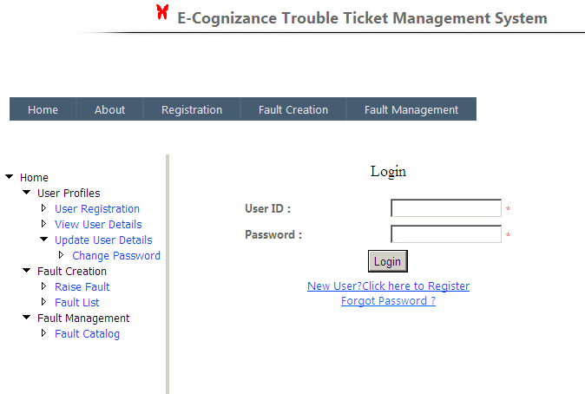

This is the very first page of our website Login Page. Here login details are given and on clicking the login button as per the log in data the page will redirect to either agent home page or the user start page.
The user enters the user name or password in this page. If both are correct then he is logged in or else an error message is displayed.

5.2.1 Maintaining User Registration Page

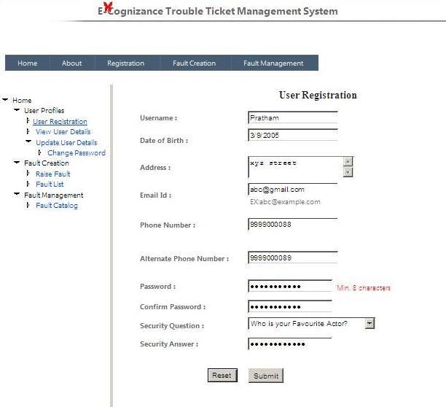

This page is used for customer registration. A customer with any Fault has to register to get a valid userID for login and proceed with Fault addressal.

5.2.2 Maintaining View User Details Page

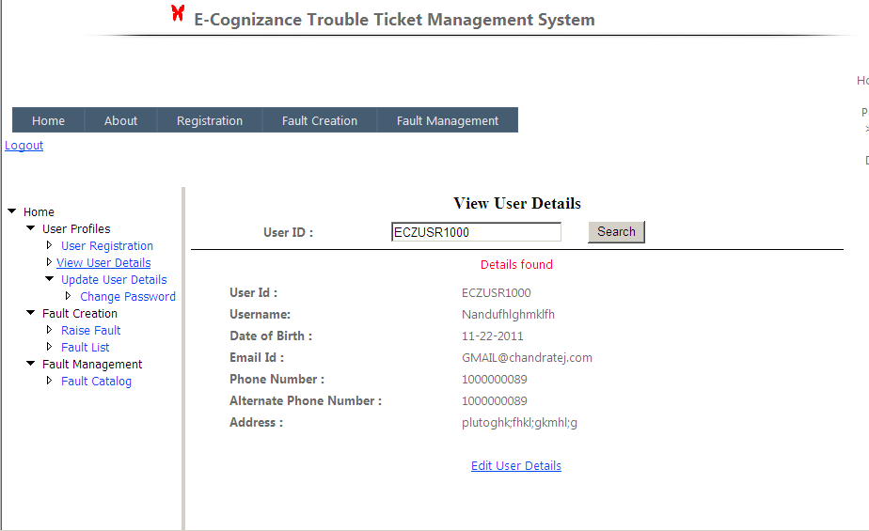

In this page,user can view/search for profile information by entering the user ID. By default, logged in user's info is displayed and a link is provided to Edit User Details page. Otherwise, the corresponding results are displayed according to search.

5.2.3 Maintaining Edit User Details Page
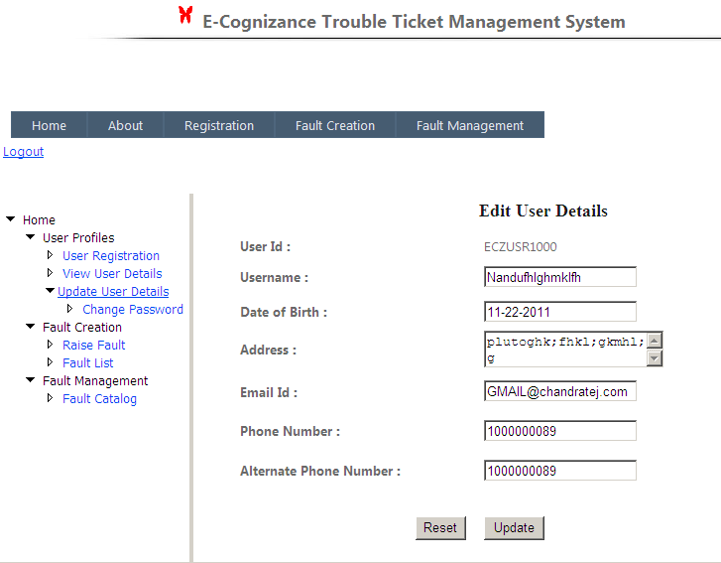

.In this page, user can edit his/her profile information after the registration is successful.

5.2.4 Forgot Password

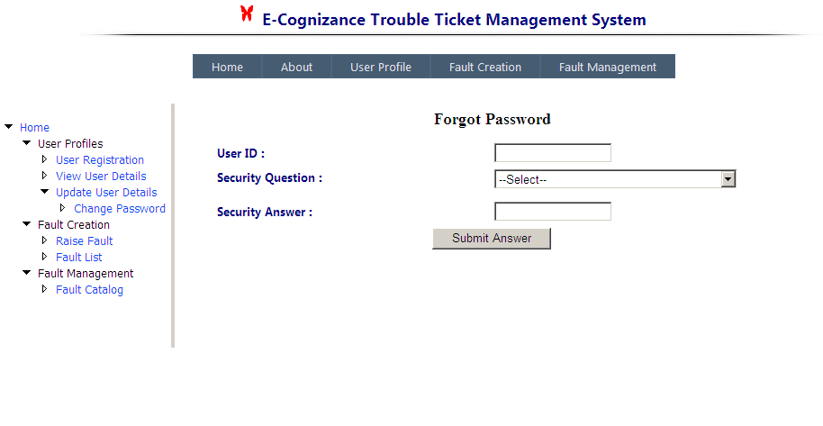

If the user forgets the password, security question needs to be answered which he has filled while registering.

    - Change Password

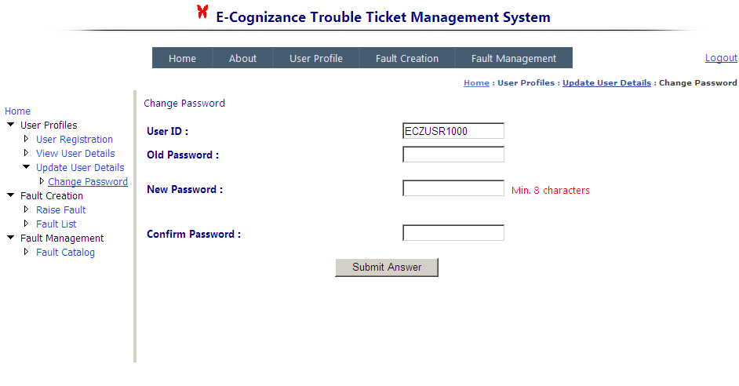
When the user forgets his password it is reset to his userid and then he can change his password.

5.2.6 Maintaining Raise a Fault Page

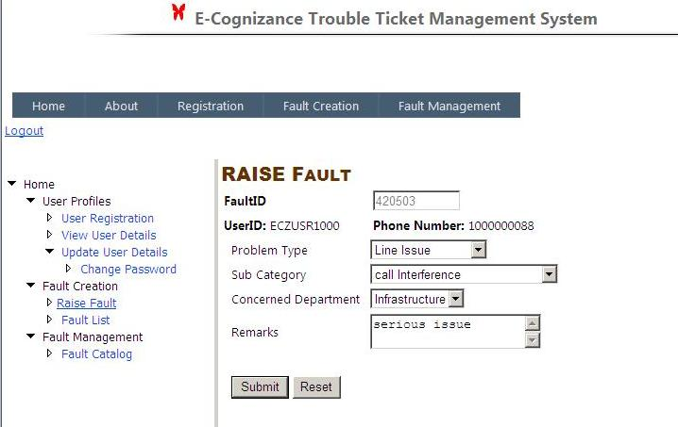

This page can be used by a registered user to raise a Fault. While entering the user should select the problem type,sub-category type.

5.2.7 Maintaining Fault List page

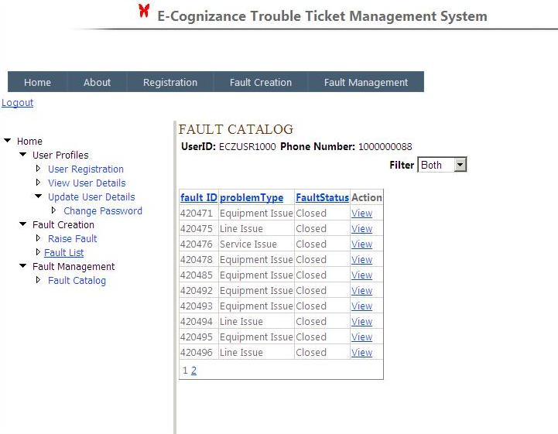

In this page, a collective summary is provided to the User in which he/she can view, update or sort the Faults raised by him/her till now.

5.2.8 Maintaining Fault details

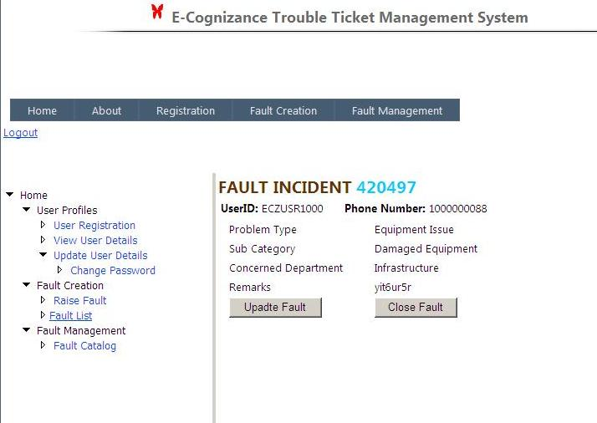

This page is visible to the User(one who has raised a Fault ) after he clicks/selects a particular Fault id description.

5.2.9 Maintaining View Faults

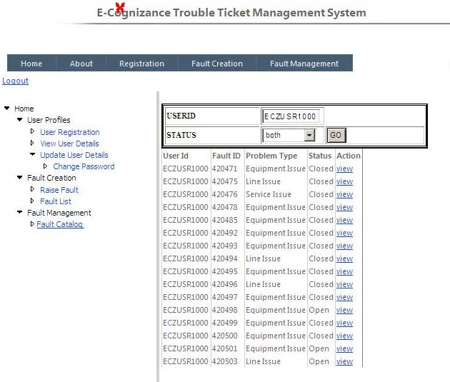

This page is visible to the Agent after he/she selects a particular Fault for viewing.

5.2.10 Maintaining View Fault Details

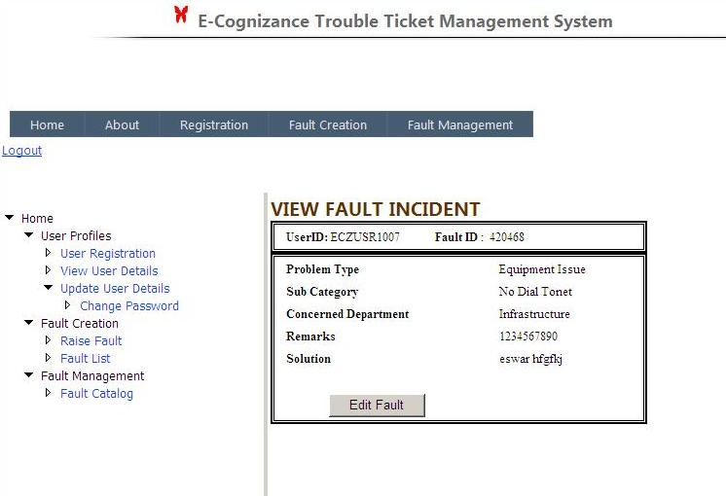

This page provides a collective summary to the Agent regarding the particular Fault that have been raised leaving the solution empty. After the Fault is closed by the user the Edit Fault button changes to Delete option for the Agent.

5.2.11 Maintaining Update Fault

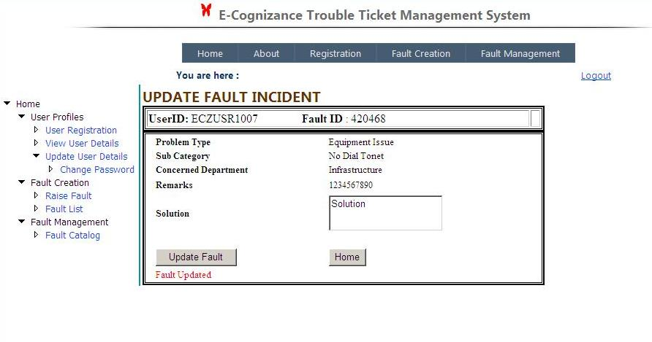

This page provides a collective summary to the Agent regarding the particular Faults that have been raised .After the Fault is closed by the user the update button changes to Delete option for the Agent.

5.2.12 Maintaining Delete Fault

`

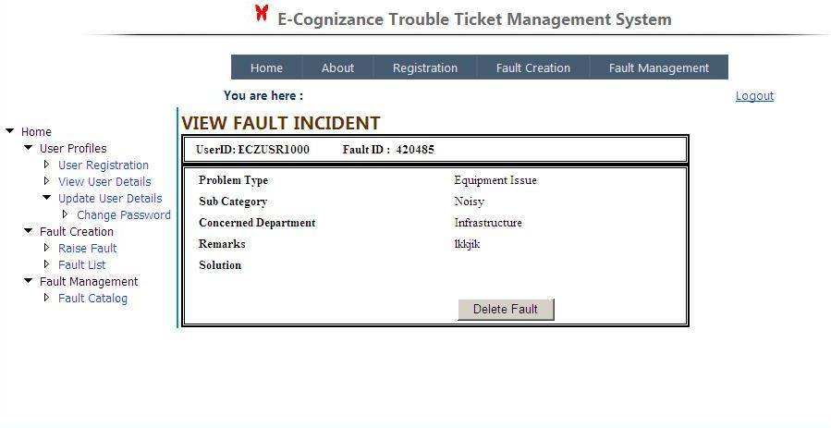

In this Page if once the raised fault is resolved and closed by the user then the agent can delete the fault.

